Ryde Town Hall, Lind Street, Ryde, Isle of Wight

Ryde Town Hall was built as a market house and town hall in 1829-31 by James Sanderson. It was extended in 1856 and more dramatically by Francis Newman in 1867-9, when the town acquired borough status; a series of phased alterations included a new council chamber and assembly hall, which thereafter took precedence as the market went into steep decline. The council chamber survives, but the halls were substantially rebuilt in 1933-4 following a fire and remodelled as a theatre in 1990-1. Elements from all these phases of construction survive, contributing to a surprisingly complex and intriguing building.

A Background to Ryde
Ryde developed as a fashionable resort from the 1790s, W. H. Davenport Adams in 1866 describing its growth over the previous half century as ‘extraordinary’. Its origins lay in two hamlets, one by the shore (in origin La Rye) and a larger one on the hill. In 1705 Sir John Dillington sold the estate to Henry Player, a Hampshire brewer, and it was duly inherited by his son Thomas and grandson William. The first developments were made by William, who laid a new road on the line of a packway to the quay at Lower Ryde in 1781, but it was his widow, Jane, who following his death in 1792 began to grant leases for building. These were first concentrated on the new road, which in 1801 became Union Street, but more development followed in the 1810s when her son George Player and son-in-law Dr John Lind settled in the town and took an active interest in its growth. Jane Player split her husband’s legacy equably between her heirs, determining the future Player and Lind estates so fairly that some streets were split lengthways to give them one side each. George Player commissioned the London architect James Sanderson to design Brigstocke Terrace in 1826 and to rebuild St Thomas’s Church in 1827, but it was Lind and his son James P. Lind (1790-1860) who built most of the new housing. The construction of the pier in 1813-14 and its progressive extension brought more visitors to the resort, noted for its benign winter climate; the arrival of a railway from London at Gosport in 1839 and at Portsmouth in 1847 increased its popularity still further. The permanent population similarly grew, rising from less than a thousand in 1801 to 1601 in 1811; 2876 in 1821; 3676 in 1831 and 5840 in 1841; by 1862 it had reached about 8000.

George Player and John Lind were involved in the development of Ryde Pier and in the petition for an Improvement Act to introduce a measure of local government to the town, which in 1829 was officially no more than an outpost of the large parish of Newchurch. An Act for Paving, Lighting, Cleansing and otherwise Improving the Town of Ryde in the County of Southampton, and for Establishing a Market within the said Town, was duly passed that year. It established a board of 27 commissioners, to be annually elected from among the most prosperous townsmen by the ratepayers. In practice the Newchurch vestry and highways commission retained control over most of the town’s services, and only in the building of a market did the new commissioners have a free hand. Its building followed an attempt to erect a market at St Thomas’s Square, where instead the Theatre Royal had been erected in the early 1800s (rebuilt in 1871 and destroyed by fire in 1961, its site is now that of the Nat West Bank of 1966-7).

The Market Hall 1830-1
The original town hall was a symmetrical, neo-classical building with a temple-like appearance to its main, south-facing elevation. It belongs to a distinguished group of public buildings from the 1820s and early 1830s that adopted this idiom, with either Greek or Roman details; a gesture towards the origins of democracy was thought appropriate for a public building. Birmingham Town Hall, built in 1832-4 following a Town Improvement Act of 1828 and listed grade I, is perhaps the most obvious example, but others range from Manchester Town Hall of 1822-5 to the modest Halifax Assembly Rooms of 1828. However, for such a relatively small and very recent settlement to build such an ambitious and refined structure was remarkable. Built of honey coloured stone in pieces no larger than bricks, it was single-storey save in the centre, where a first-floor temple complete with an portico and two small end pavilions sat on top of an open five-bay colonnade. The five-bay, single-storey wings ended in a slightly projecting and somewhat taller three-bay pavilion, as survives at the west end; the wings had only small rectangular windows set high under the deep cornice, while the pavilions had three arches, the central ones open in the undated engraving below. It was the largest public building on the island until the county offices were erected at Newport.

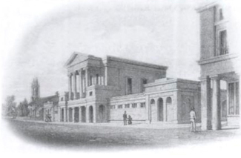

The Market House and Town Hall, before 1856

In 1833, George Brannon described the ‘Market House in Lind Street’ as:
a handsome building having a frontage to the south of 198 feet. At the west end is the Fish Market, near it are Butchers’ shops and a pump of excellent water. The centre is intended for the Corn Market; and the eastern division is appropriated to the general market, which is well supplied with fish, meat, fruit, vegetables, poultry etc. … The market days are Tuesdays and Fridays but the market is open daily for the wants of residents. The cattle market is in front of the building.

The town hall is erected over the Corn Market, being the centre of the building. It consists of an elegant room 44 feet by 26, opening by sliding doors into a room 15 ft by 20, where the commissioners for improving the town hold monthly meetings. When both rooms are thrown into one, it forms a room 60 feet in length. The view from this apartment is very extensive and delightful. Balls are occasionally held here.
Brannon’s words were repeated almost verbatim by Thomas Brettell in 1840. The cattle market proved unsuccessful, however, and Brannon reported in 1842 that it had closed, that in Newport remaining more convenient for the island’s agricultural interests. Nevertheless he was quick to complement the building itself. ‘The Town-hall and Market-house affords the best proof of the public spirit of the inhabitants of Ryde in regard to local improvements; for this handsome edifice is on a scale to accommodate three or four times the present population.’

The most detailed early description is that of c.1838 by Samuel Horsey junior:
The foundation of this magnificent building was laid the 14 of May 1830 by the late John Lind of Westmont Esq. The front elevation is very commanding. The centre principal building is adorned with a lofty portico of four columns of the Ionic order, resting upon a Doric colonnade, terminated on each side with a wing supporting an attic. On the right is the staircase to the town hall, and the clerk’s office; on the left are the porter’s rooms and the weighing room, where purchasers may have their articles weighed.

In the centre above the market is the town hall. This elegant room is 45 [feet] in length 27 in breadth and 20 in height. The market is enclosed by a wall, which is ornamented by a range of small elegant pillars.

This spacious market-place, which is 196 feet in length, 56 in width, in addition to the useful purposes to which such buildings are applied, has two wings with shops on each side for the accommodation of all kinds of business.

This beautiful piece of architecture, which adds so much to the dignity and convenience of the town, as well as the fine Gothic church and the adjacent terrace, were designed by James Sanderson Esq and are fine specimens of the accomplished talent and taste of the architect.

John Albin gives Lord Yarborough the honour of laying the foundation stone, but the trowel that was used survives and records that Lind did the deed; Yarborough was present when William Sheridan laid the coping stone at the top of the building in June 1831.

Something of the grandeur of the first floor hall, now the ‘small hall’ or bar area, can be divined from the three tall sash windows facing Market Street, but the enclosed arcade below is shown as open on James Courtney’s map of 1836. Some pilasters – presumably the ‘small elegant pillars’ described by Horsey – survive on the west wing of this elevation. The street to the north, originally Little Cross Street, was renamed Market Street by 1836, suggesting that the market could be entered from this side. The weighbridge was in Lind Street, however. The 25” Ordnance Survey map of 1864 shows the eastern wing with a central covered space lined by small shops on each of the two long sides, entered from St James’s Street or through the south side of the end pavilions. The first cattle market was held on 26 June 1833, when the commissioners hoped to attract business by sea from towns along the coast as far as Brighton.

James Sanderson (c.1791-1835) was born in East Grinstead and was a pupil of Jeffry Wyatville in 1813-16. Although his practice was based in Cork Street, London, most of the buildings he completed in his short career were on the Isle of Wight, where he produced an adventurous range of buildings that began with villas at St Clare/ Puckpool, just east of Ryde and the Gothic Steephill Castle near Ventnor before working for George Player at Brigstocke Terrace and St Thomas’s Church.

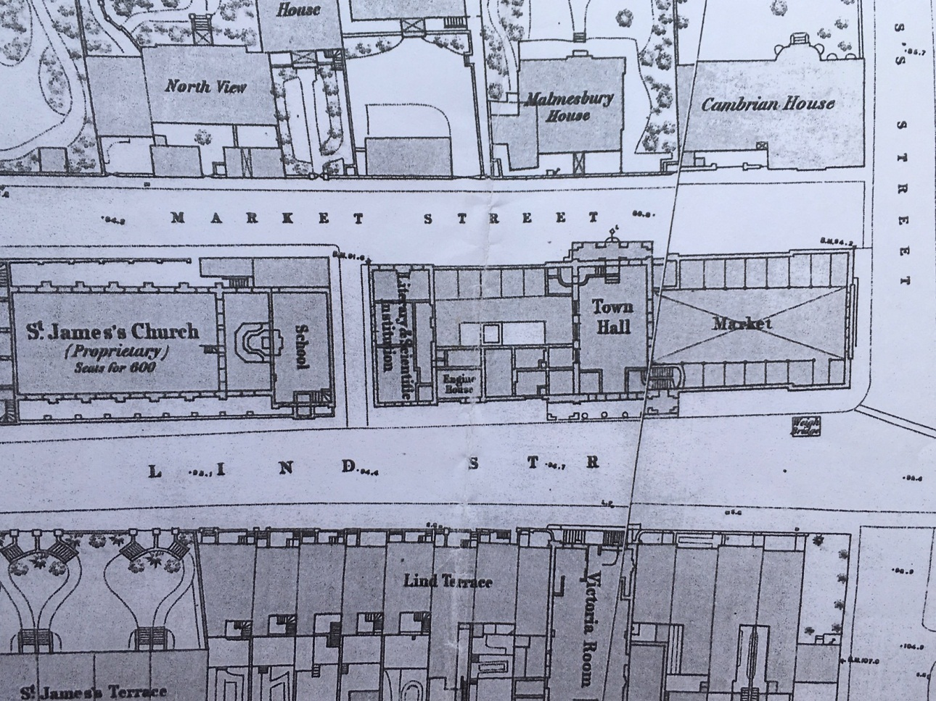

25” Ordnance Survey, 1864 (in two parts)

Alterations and Additions 1856-69
The market’s popularity proved short-lived. In 1848, H. R. Holloway described the town hall and market as ‘an extensive and ornamental, although it must be admitted, comparatively useless building, in Lind Street; entailing as it does, a heavy pecuniary burden on the rate-payers’. In 1863 the Isle of Wight Observer reported that the market was ‘filthy and neglected’. ‘For bad management, Ryde Market stands A1. In fact it can hardly be called a market, there being no competition of any kind. The only retail shops at present let are one fishmonger, one poulterer and two greengrocers.’

A town hall historically means just that – a hall or assembly room operated by the municipal authorities, as is exemplified by that at Birmingham. Fashionable Ryde had other assembly rooms, in Union Street (by 1818), at the Crown Inn and at the Victoria Rooms built in Lind Street across the road from the town hall in 1853-4. But there was a high demand for the town hall’s first-floor space for balls and concerts, as reported in the local paper founded in 1848, and Holloway noted that year that ‘Petty Sessions are held every alternate Thursday in the Hall itself; and in addition to its legitimate use, is often appropriated for balls, concerts, etc.’.

The commissioners meanwhile busied themselves in establishing proper public services in Ryde, and freeing the town from Newchurch. In 1847 they secured control of all roads within the town, and following an outbreak of cholera in 1849 they secured a second Improvement Act in 1854 to set up a local board of 27 residents and provide a new water supply. A further Act in 1861 increased this supply, obtained from Knighton. Ryde finally became a separate ecclesiastical parish following the Newchurch Parish Act in 1866.

The north elevation of the town hall building today is confusing and largely rebuilt, even at the low western end, with a mezzanine along the north elevation of this wing. The western pavilion became the library and lecture room of the Ryde Literary and Scientific Institution, founded before 1848, when it occupied premises in St James’s Square (not a name that exists today, but presumably nearby; there was a Ryde Book Institution on Union Street in 1836). A fireplace in the north-west corner room of the town hall building could date from the 1850s. Part of the west wing was also taken by an ‘engine house’ for the town’s fire engine. In February 1856 the board invited tenders for ‘making new fronts to the south and east shops of the Ryde Market and enclosing the north end of the Fish Market’, to plans by the town surveyor Francis Newman. By November alterations were in hand to raise the hall’s capacity from 300 to 500 people, with space for an orchestra and waiting rooms on the west side and a separate room on the east that could be used separately or together; a small stair on the north-east side was to link the refreshment room and kitchen. This work was to cost £700. Little of this work survives, but the map of 1864 shows something of these alterations and the changing use of the building ahead of its more substantial redevelopment in subsequent years. It shows that an open area remained on the west side, perhaps top-lit and with a line of shops or stalls against the north wall. However, in 1866 Davenport Adams reported that only the east wing, where two lines of shops of stalls lined a central open area, was in use as a market.

The complex elevation to Market Street bears witness to further alterations by Newman, made in three phases in 1864, 1867 and 1868-9. They are a little more coherent to Lind and St James’s streets. A special meeting of the local board was held on 18 November 1863 to discuss Newman’s plans for ‘converting part of the western end of the Ryde market into a room for transacting such public business relating to the town as the Commissions shall from time to time direct or allow to be held or transacted therein’. This was the origin of the present council chamber, perhaps adapted from the ‘orchestra and waiting rooms’ of 1856.

More work followed in 1867-9 ahead of the town becoming a municipal borough in 1868. The new borough comprised most of the new parish of Ryde and a small portion of St Helen’s, divided into east and west wards, and served by a mayor, six aldermen and eighteen councillors. As well as taking responsibility for gas, paving and water, the new corporation could now make its own police arrangements. First came a new clock tower, the plan prepared ‘by the kind assistance of Mr Thomas Dashwood’, a member of the board and to whom the design is normally credited, though Dashwood himself referenced ‘the architect’, presumably again Newman. The clock had been presented by Miss Mary Harriette Player Brigstocke (1824-1904), grand-daughter of George Player. Dashwood commented that ‘it certainly was becoming of the town to erect a suitable tower or turret to receive the gift so generously made to the town’, and that (on the architect’s advice) they should take the opportunity to erect a gallery to the council chamber seating 75 people that would also help to support the tower, as well as an auction room. The lowest tender received on 2 March 1867 was from Henry Loe, at £671 10s, somewhat less than the work of 1856. The Isle of Wight Observer described Thomas Dashwood 1879 – along with Newman – as ‘an architect and surveyor’, in succession to his father (also Thomas) who had been the builder of the original town hall and market along with many buildings in the town, some to his own designs. Thomas junior was elected the first mayor in 1868, and two members of his family also served on the first council.

It was at the same meeting on 2 March 1867 that Thomas Dashwood first proposed building an assembly hall over the eastern market, at a cost of over £2,000, arguing that a large hall seating 750 people was urgently needed. The detailed plans, discussed in October, promised an entirely top-lit hall that would be suitable for exhibitions, and below it a market hall entered from St James’s Street with nine shops (only three were let at that time). They were approved by a narrow majority of eleven votes to seven, with two abstentions, and tenders were sought in the same month. The old hall was retained as the ‘small hall’. A tender from Parsons and Saunders was accepted in November.

During the building operation, between February 1868 and March 1869, the market was held in the space below the new council chamber, which was itself used for concerts. That held in January 1868 was described in some detail.
The first concert for the present season took place at the Town Hall on Thursday evening, which was thoroughly crowded, the room presenting an unusually pretty appearance from a charming piece of scenery placed at the back of the platform. The new gallery was found especially convenient on this occasion, and but for some local circumstances to which we need not allude, this concert would really have required the new assembly room.
A supper to celebrate the roofing in was held in May 1868 to celebrate the roofing-in of the new assembly room, with Thomas Dashwood taking the principal seat.

The additions and alterations made by Francis Newman are in an Italianate style, using a slightly greyer stone in larger pieces than that chosen by Sanderson. The upper order and pediment were now flanked by two new bays, so the Ionic columns are now set in antis, with to the west a single set-back bay that contains the main stair and the stair to the new gallery, which retains its original built-in bench seating. Newman repeated the Ionic order over the eastern pavilion and as a centrepiece to the return elevation on St James’s Street. The round headed openings in the west wing were infilled, with below them new sash windows whose character was repeated on a larger scale on the first floor of the new assembly room, with a different treatment to the ground floor, now faced in stone. The ground floor to St James’s Street was left open as a narrow arcade. The 1856 work may be denoted by glazing bars to the windows on Market Street and to the council chamber, the larger windows with only margin lights. Francis Newman (1831-1904) had served articles with his father James before in 1856 he was elected surveyor to the Ryde Commissioners, a post he continued to hold for the new council until 1897, save for a break in 1872-5 when local power passed to a controversial faction led by Henry Knight – arch rival of the Dashwood family and its supporters. The post made him the most important architect in Ryde and one of the most significant on the Island.

The original building programme that intended the building to be completed in July 1868 was over ambitious, and it was delayed by poor weather and a stallholder, Mr Hunt, who refused to move into the temporary accommodation under the new council chamber. In related work, a new home was found for the fire engine and escape ladder, and the old engine house in the west wing was converted into a second office for the town clerk.

Reaction to the new assembly hall was surprisingly muted. In June 1868 the Isle of Wight Observer noted that work was progressing well and that ‘the building seems to be especially attractive to visitors, and will be a permanent ornament to the town’. The paper repeated this comment in August, when the scaffolding began to be taken down at last. The building was finally opened on Tuesday, 13 April 1869 with a meal and entertainment for poor persons of the town aged over fifty, hosted by Mrs Dashwood, the mayor’s wife. Some four hundred invites were issued and the rest of the hall, which seated over 700 people, was filled with the general public. An account of a concert in July proclaimed that ‘the hall was in good trim. A very prominent object on the walls was the beautiful picture from the easel of Mr Fowles, of George Street.’ More pictures from Arthur Wellington Fowles (1815-83), a prominent marine artist born and raised in the town, followed.

The Observer’s muted reaction may have reflected problems with the building. The sheet glass to the corridor windows and dormers was found to be defective. ‘Alderman Paul said the room was universally admired but the glass had been as generally condemned’; however the cost of replacing 24 panes of glass each 10ft by 2ft was too much. Newman was also captain commandant of the Isle of Wight Rifle Volunteers and organised a drill in March 1869 to test the floor, only to find that it needed strengthening. The question quickly arose of further additions, probably for a court and police station.

In April 1870 the Observer printed a letter from one Richard James Jones, who explained that ‘everyone is aware that the Town-hall as it now exists is incomplete; that another wing, similar to the one built last year containing the Assembly-room and Market, will have to be built on the west side of the clock tower. On that, everyone is agreed. But the question is, shall it be done now or at some future time?’ His call for delay was clearly followed. Had the new building been overly ambitious? The existing assembly halls in the town had rarely been filled, and the Hampshire Advertiser reported in 1869 that ‘we have often heard opinions expressed that the new assembly room was not required in the town of Ryde. … however, on the occasion of the exhibition of dissolving views, at the instance of the YMCA, there were no less than 900 persons present.’ Such a full house was a rarity.

The label ‘old market’ appeared on the 25” Ordnance Survey Map of 1907, but ‘old’ might already have meant ‘defunct’. In 1894 the Isle of Wight Observer commented that ‘the “Decline and Fall of Ryde Market” is a very doleful book. … “The dismal line of shutters in the Market-place clearly shows that these are its closing days, and the empty stalls proclaim that the play is over”.’ The space was being used for storing ‘grimy old chairs’. Yet alterations and improvements continued to be made to the assembly hall. In 1895 the mayor of Ryde convened a meeting to oppose the building of council offices at Newport, ‘when they can obtain all the accommodation in the municipal buildings at Ryde’.

However, there was greater public interest in the commemoration of Queen Victoria’s Diamond Jubilee. The main memorial was a children’s wing added to the Royal Isle of Wight Infirmary and County Hospital by the specialist architects Young & Hall, built at the behest of Princess Beatrice, but the Ryde council felt also that there should also be a local initiative. Its choice fell on a three-manual Walker organ for the assembly hall, which took up much of the small platform there. Sufficient funds were raised by the end of 1897 for its installation by July 1898, although it was not fully paid for until a ‘Grand Fancye Faire’ in the hall raised £650 in 1902.

The Isle of Wight Observer reported of the organ that ‘It takes up the whole of the back of the platform and comes forward to within about 4ft of the edge of the permanent platform. It is handsomely panelled, with ornamented pipes above. In the front is to be a medallion portrait of the Queen, with 1837 and 1897 on either side.’ A photograph taken soon after its installation show a proscenium of heavy composite pilasters in antis to either side of the stage, with paintings and fewer, larger pilasters on the flanking walls; there was a door by the platform and two pairs of heavy doors leading to the vestibule on the south front.

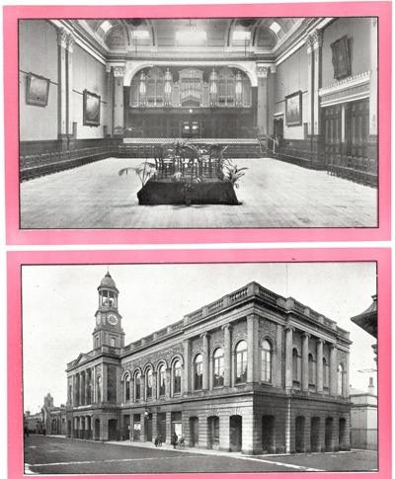 The Town Hall c.1900 (Historic Ryde Society)

Outside on Lind Street, a glass canopy to the entrance was erected in 1902 and taken down in 1950. Concerts became popular at the town hall, although complaints continued, the Isle of Wight Observer commenting in 1905 that there was no advantage to the best (5 shilling) seats save a position at the front and calling for more comfortable tip-up seats. A war memorial bearing 361 names was unveiled by the Marquis of Carisbrooke inside the large hall in 1922. The town hall was also used at various times by the county library service, established in 1904 at the behest of Sir Charles Seely and the first county service in the country. As well as commissioning the Technical Institute and Seely Library in Newport that year, Sir Charles devised a series of lockable bookcases which were circulated round the island, including at Ryde, where reference facilities were available in the town hall from 1907. The town secured larger premises at the school of art in 1933, but the town hall was used again in 1934 before larger and more permanent facilities opened at the YMCA in Lind Street in 1935.

Fire and Rebuilding 1933-4
On 17 December 1932 the town suffered a minor scare when there was a small fire in the woodwork behind the back of the organ, blamed on a match or cigarette. The hall keeper and town sargeant, Frank Barrett, found the large hall full of smoke but quickly put the fire out, earning praise both for himself and his modest fire extinguisher. When on 6 June Mr Barrett discovered another fire while most of the staff and petty sessions court were at lunch and a rehearsal in the hall just concluded, he and his assistant again tried to put it out himself while waiting for the fire brigade. But this fire was in the roof and neither Barrett and his assistant, nor the Ryde Fire Brigade, nor those from Newport and Sandown, could get sufficient pressure to reach so high an elevation, and were further hindered by wind fanning the flames. They managed to contain the fire to the large hall by 3.30pm, but could not save the roof, nor the organ and its platform below. Two of Arthur Fowles’s mammoth seascapes were also lost, though two more, depicting a ship leaving Portsmouth Harbour with the remains of the American millionaire George Peabody and the other of Cambria winning the town cup at the Royal Victoria Yacht Club’s regatta in 1868 were saved. The latter is now with the Isle of Wight Council Heritage Service. A painting of Venus presented by Miss Brigstocke was also saved, and a clock over the central entrance to the hall was said to have carried on ticking throughout the commotion.

There was water damage to the court room and reference library, which were presumably set below the hall, but stout doors prevented the fire spreading to the small hall alongside and to the council chamber beyond. Staff quickly removed the corporation silver, the library, and the Daily Herald reported how ‘holiday-makers, many of whom were clad in swimming and beach suits, rendered valuable assistance and help to salvage record books and documents’. Other items salvaged included cases of stuffed birds, fossils and Egyptian mummies. The Isle of Wight County Press blamed the fire on the hot sun that poured through the dormer windows in the roof even though it had started in the north-east corner. This was national news, with reports not only in the Daily Herald but also the Scotsman (which had the best photograph of the blaze).

The building, organ and paintings were all insured, and the council quickly set to work to reconstruct the main hall to the designs of Eiloarth, Sons and Inman (later Eiloarth, Inman and Nunn, a London firm). The plans produced in October 1933 replaced the pitched roof with a flat one supported on steel girders. It took out a central staircase to the large hall to make more room for kitchens below, linked by a service lift, but introduced an iron fire escape on the north elevation leading from the small hall (which survives). This was designed to make it easier to hold conferences and banquets. A new staircase in the lobby between the two halls served a gallery above the small hall, which was extended for lavatories and dressing rooms, which survive, and folding doors were introduced so that the two halls could be thrown together when needed; a maple dance floor was installed in both spaces. In the large hall the giant order of paired pilasters was recreated but although the proportions of the wall panelling were retained the rich hardwood dado and moulded doors were not replaced, nor the elaborate decoration above the latter. A new organ, its pipes set in two halves across the back of the stage, proscenium and sloping platform were installed. The trabeated ceiling was renewed, but not the dormer windows within the cove above its heavy cornice. The Portsmouth Evening News reported hopes that the work would be completed before the Ryde Music Festival in May 1934. A contract was awarded in December to Messrs Roussell & Sons in December and work had begun by 13 January 1934, but the hall did not reopen until 1 June. One major change was the removal of the war memorial to a new, more reverent position within the old ground-floor colonnade, with its own arch vault.

The organ was restored in 1980-5, when the Ryde Toan Hall Organ Trust was formed.

The Ryde Theatre, 1990-1
The glass canopy added in 1902 was removed in 1950 but otherwise there were few alterations made to the town hall until 1990. In in that year, however, Nigel Hayton converted the main hall into a theatre and cinema, with a large raked balcony that included a sound and projection box as well as refurbished dressing rooms, a new bar and box office. The proscenium seems to have been removed at this time in favour of curtains. The building was renamed the Ryde Theatre.

The new theatre opened in March 1991 seating 500 people and enjoyed a limited success, but films failed the same year, and again in 1993. The building closed in April 2010 and put up for sale; a drama group Platform One had to pull out in 2011. Instead it was sold in 2013 for c.£300,000 and it has not reopened. In August 2020 there had been some damage to the organ (broken glass), but otherwise the building was in reasonable condition.

Conclusion: Reasons for Special Interest
A major public building that is a physical symbol of the growth of Ryde as a town; its alterations and additions are part of the history of this development
A very good example of the neo-classical style, now rare, symbolically used for public buildings at the beginning of the twentieth century
An important example of the work of James Sanderson, whose major buildings are in Ryde and who was the most significant architect in the town’s early development
The list description does not describe the interior, which retains its 1860s council chamber and 1860s/1930s main hall, as well as nineteenth-century staircases and fireplaces elsewhere in the building

Elain Harwood
March 2021

. W. H. Davenport Adams, Nelson’s Hand-Book of the Isle of Wight; its history, topography and antiquities, London, T. Nelson & Sons, 1866, p.107.
. I. M. Hocking, ‘Development of Ryde as a Resort and Passenger Port, 1780-1914’, unpublished PhD, no title page, 1980.
. W. H. Davenport Adams, op.cit., p.107.
. Anthony Peers, Birmingham Town Hall, An architectural history, London, Lund Humphries, 2012.
. George Brannon, The Pleasure Visitor’s Companion in Surveying the Isle of Wight, Wooton (Isle of Wight), 1833, pp.65-6.
. Thomas Brettell, Topographic and Historical Guide to the Isle of Wight, comprising authentic accounts of its antiquities, natural productions and romantic scenery, London, Leigh & Co., 1840, p.33.
. George Brannon, Brannon’s Picture of the Isle of Wight, or the Expeditious Traveller’s index to its prominent beauties, and objects of interest, Wootton, George Brannon, 1842, p.47.
. Samuel Horsey junior, The Beauties of the Isle of Wight, London, Longman, fifth edition 1838, pp.52-3.
. John Albin, Companion to the Isle of Wight, London, Longman, 1831, p.54; Diana Wood, The Early Years of Ryde Town Hall, Ryde, Ryde Historical Society, 2011, flyleaf.
. Hampshire Telegraph and Sussex Chronicle, no.1760, 29 June 1833, p.4.
. Henry Richard Holloway, Walks Around Ryde, London, Longman & Co., second edition, 1848, p.27.
. Isle of Wight Observer, no.557, 2 May 1863, p.3.
. Isle of Wight Observer, no.181, 16 February 1856, p.1.
. Source unknown, quoted in Wood, op. cit., p.13.
. Ordnance Survey maps of Ryde, first edition XCI.9.15 and XCI.10.11, 1864-5.
. Hampshire Telegraph and Sussex Chronicle, vol.63, no.3346, 21 November 1863, p.7.
. Proceedings of the Ryde Commissioners, 1866-71, Isle of Wight Archives.
. Hampshire Advertiser, vol.44, no.2268, 16 February 1867, p.8; Isle of Wight Observer, no.757, 2 March 1867, p.3.
. Isle of Wight Observer, no.757, 2 March 1867, p.3.
. Isle of Wight Observer, no.1394, 9 August 1879, p.8.
. Isle of Wight Observer, no.803, 18 January 1868, p.3.
. Isle of Wight Observer, no.821, 23 May 1868, p.3.
. Francis Newman’s brother James built town halls at Brading and Cowes.
. Isle of Wight Observer, no.794, 16 November 1867, p.1; no.850, 12 December 1868, p.3.
. Isle of Wight Observer, no.824, 13 June 1868, p.3; no.834, 22 August 1868, p.3.
. Hampshire Advertiser, vol.46, no.2382, 10 April 1869, p.8.
. Hampshire Telegraph and Sussex Chronicle, no.3853, 21 July 1869, p.4.
. Hampshire Telegraph and Sussex Chronicle, no.3816, 13 March 1869, p.7.
. Isle of Wight Observer, no.919, 9 April 1870, p.3.
. Hampshire Advertiser, vol.47, no.2436, 16 October 1869, p.8.
. Isle of Wight Observer, no.2179, 2 June 1894, p.5.
. Isle of Wight Observer, no.2218, 2 March 1895, p.5.
. Isle of Wight Observer, no.2395, 16 July 1898, p.8.
. Isle of Wight Observer, no.2738, 18 February 1905, p.5.
. Westminster Gazette, 14 August 1922, p.7.
. Portsmouth Evening News, no.17441, 6 June 1933, p.4; http://woottonbridgeiow.org.uk/library/chapter5.php, accessed 3 March 2021.
. Daily Herald, no.5401, 7 June 1933, p.16.
. Isle of Wight County Press, vol.49, no.2533, 10 June 1933, p.3.
. The Scotsman, 7 June 1933, p.16.
. Isle of Wight County Press, vol.50, no. 2607, p.3.
. Isle of Wight County Press, vol.49, no.2546, 9 September 1933, p.5; no.2551, 14 October 1933, p.8; Portsmouth Evening News, no.17551, 12 October 1933, p.3.
. Portsmouth Evening News, no.17551, 11 October 1933, p.5.
. Isle of Wight County Press, vol.50, no.2564, 13 January 1934, p.8.

